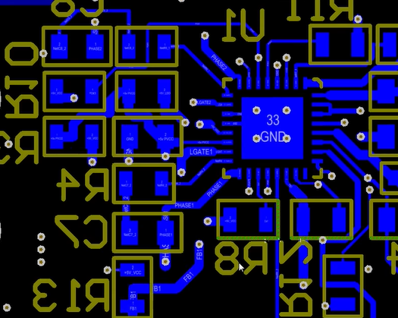
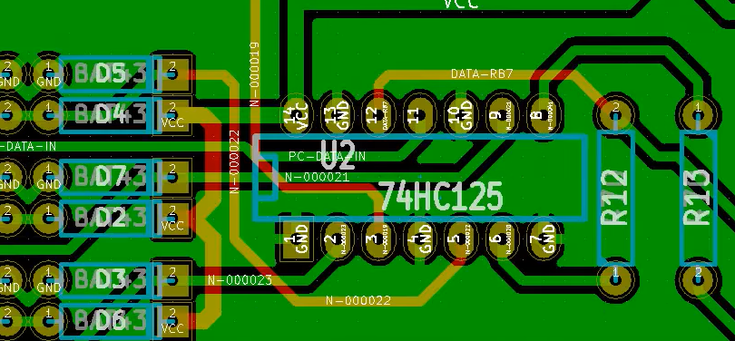

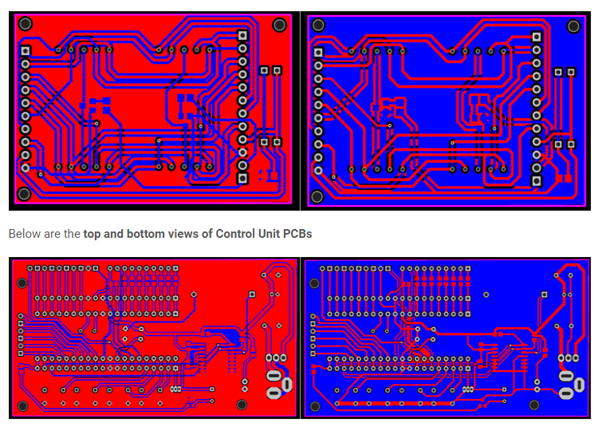

9
First step is to design the circuit and draw the schematic. The schematic should be easily readable and not too dense. General rules:
- Power flows from top to bottom (place positive voltages on top, negative and ground on the bottom)
- Signal flows from left to right (except for feedback loops)
- Tag power and ground with the appropriate symbols and keep individual net segments short (don't try to connect all the grounds on an entire sheet with the same line, add ground symbols to make it easier to follow)
- Tag signals that connect off-sheet
Once the schematic is complete, move on to the board layout. Sometimes changing the schematic will simplify the layout as well, so don't rule out going back to the schematic and swapping around which device in a quad op-amp chip or a quad or hex logic gate chip are used for what purpose.
General procedure for laying out the board is relatively simple. There are two main steps: placement and routing. The art of board layout is in the placement. Bad placement, and routing is a real pain. Good placement, and the board practically routes itself. The goal of placement is to untangle the 'rat's nest' of airwires as much as possible, while locating the components in an approximation of their final location. It is a good idea to test route related components to get a feel for how they will connect. Sometimes it takes several tries to get all the kinks worked out. Don't be afraid to rip up and reroute - the more you route stuff, the better you'll get. It may be advisable to restart the layout if it's a complex layout and you don't like the overall placement. Generally you'll be able to produce a much more concise layout the 2nd time around.
To place a board, start with components with external constraints (connectors, switches, heatsinked components, antennas, etc.). Then move on to high pin count devices. Try to compartmentalize the board into various functions and orient the high pin count components so it will be eaiser to route the traces. Then start filling in the smaller components. Try to get the parts laid out in such a way that they can be connected simply. It helps to route a few traces here and there to see how things come together. At this point, you can go back to the schematic and make minor reassignments if it will improve the layout (sometimes called 'pinwapping' or 'gateswapping'). It takes a bit of practice to figure out how much space to leave between compoents - too much and it's hard to route, too little and it will consume a lot of area.
Once all the components are in place, start routing everything. If the placement is good, the routing should be pretty straightforward. Try to avoid vias as much as possible as they take up quite a bit of space and block rouing on all layers, but insert them where required. Sometimes flipping a specific trace to another layer (or just the other side) can make routing several others much more easily. Route components in logical blocks, and try to squeeze out as much space as possible by adjusting the component placements once you can see where the traces need to go. Once most of the blocks are routed, you can move them around a bit and get them closer together before finishing off the interconnections. Perhaps rotating some of the blocks will help, perhaps ripping up and rerouting one with a different aspect ratio will help. Once all of the traces are routed, then you can go ahead with the design roule checks and gerber file generation.

